`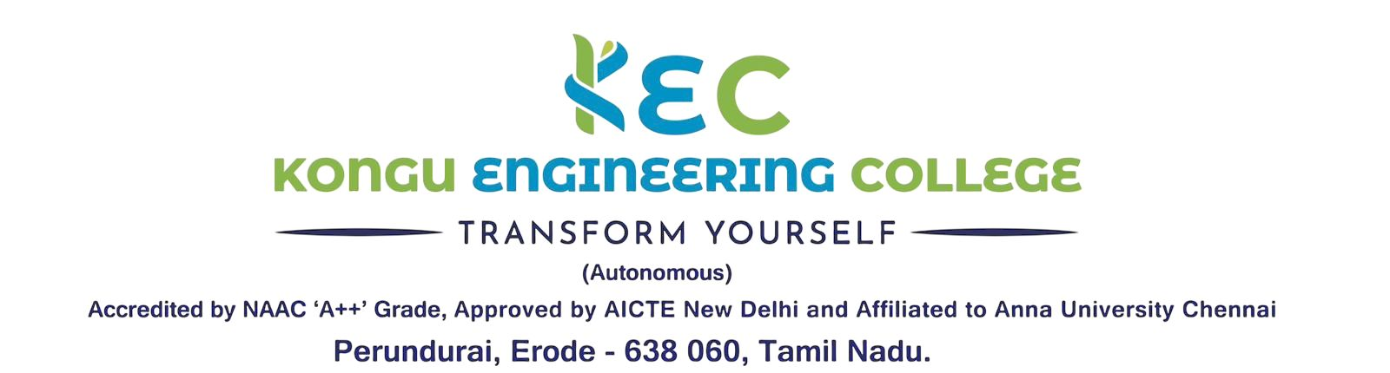 | Doc. No:  KEC/EOMS/MDI/13
 | Rev. No | 00
INTERNAL QUALITY ASSURANCE CELL | Rev. Date | 01.01.2026
NON-CONFORMITY REPORT | Issue. No | 00

Department: Date:
Non-Conformities
S.No. | Criteria | Non-Conformities | Actual level | Deviation from Quality level | Cause Analysis | Corrective Actions | Preventive Action  (if any) | Responsibility | Due date
1.
2.
3.
4.

Observations (Opportunities for improvement)

S.No. | Criteria | Observations | Cause Analysis | Action to be Taken | Preventive Action (if any) | Responsibility | Due date
1.
2.
3.
4.

Signature of Auditor | Auditee | Auditee
(Name with Designation & Dept.) | Dept. IQAC Co-ordinator | Dept. HOD

